
PT1/PHQP/1222/A 16-MAY-2022
PERIODIC TEST I (2022-23)
Subject: PHYSICS  Grade: XII |  | Max. Marks: 35  Time: 1Hour 20 Mins
Name: |  | Section: |  | Roll No:
General Instructions:
- All questions are compulsory
- This question paper has four sections: section A, Section B, Section C and Section D.
- Section A contains FIVE questions of one mark each, Section B contains FIVE questions of two marks each, Section C contains FIVE questions of three marks each, Section D contains ONE question of five marks.
- All answers to be written in the answer sheet provided.
 | SECTION- A
 | The focal length of an equiconvex lens is equal to the radius of curvature of either face. The refractive index of the material of the lens is:  - 3/2  - 2/3  - 1/3  - √3/2 |  |  |  | 1
2. | For the same angle of incidence, the angle of refraction in three different media A, B and C are 15 º, 25 º and 35 º . In which medium, will the velocity light be minimum?  - A  - B  - C  - velocity is equal in all mediums. |  |  |  | 1
3. | A prism is made of glass of unknown refractive index. A parallel beam of light is incident on a face of the prism. The angle of minimum deviation is measured to be 30°.The refractive index of the material of the prism is: (The refracting angle of the prism is 60°)  - 2  - 1/2  - √2  - 1/√2 |  |  |  | 1
4. | Suppose that the lower half of the concave mirror’s reflecting surface is covered with an opaque (non-reflective) material. Then  - image distance increases  - image distance decreases  - image intensity decreases  - image intensity increases |  |  |  | 1
5. | Which of the following statement is not true?  - Optical fibres are based on the principle of total internal reflection.  - The refractive index of the material of the core is less than that of the cladding  - An optical fibre can be used to act as an optical pipe.  - There is no appreciable loss in the intensity of the light signal while propagating through an optical fibre |  |  |  | 1
 | SECTION- B
6. | How does the angle of minimum deviation of a glass prism vary, if the incident violet light is replaced by red light? Give reason? |  |  |  | 2
7. | Two lenses are placed in contact with each other, and the focal length of combination is 80 cm. If the focal length of one lens is 20 cm, then what would be the power of the other lens? |  |  |  | 2
8. | Give the expression for magnification of compound microscope at LDDV position.? Why must both the objective and eyepiece of compound microscope have shorter focal lengths? |  |  |  | 2
9. | Derive mirror formula for a concave mirror? |  |  |  | 2
10. | A small pin fixed on a tabletop is viewed from above from 50cm. By what distance would the pin appear to be raised if it is viewed from the same point through a 15cm thick glass slab held parallel to the table? Refractive index of glass = 1.5. |  |  |  | 2
 | SECTION -C
11. | Under what conditions is the phenomenon of total internal reflection of light observed? Obtain the relation between the critical angle of incidence and the refractive index of the medium? |  |  |  | 3
12. | With the help of a proper labelled diagram, derive an expression for refraction at a spherical surface if the ray of light is travelling from rarer to denser medium? |  |  |  | 3
13. | A triangular prism of refracting angle 60° is made of a transparent material of refractive index 2 /√ 3 . A ray of light is incident normally on the face KL as shown in the figure. Trace the path of the ray as it passes through the prism and calculate the angle of emergence and angle of deviation? |  | 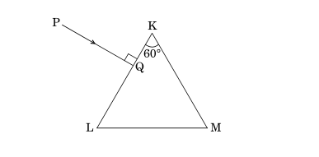 |  | 3
14. | Three lenses of focal lengths +10 cm, –10 cm and +30 cm are arranged coaxially as in the figure given below. Find the position of the final image formed by the combination.  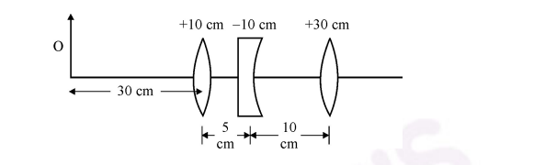 |  |  |  | 3
15. | A converging lens has a focal length of 20cm in air. It is made of a material of refractive index 1.6. If it is immersed in a liquid of refractive index 1.3, what will be its new focal length? |  |  |  | 3
 | SECTION -D
16. | - Draw a labelled ray diagram of an astronomical telescope in the normal adjustment position and derive the expression for its magnification?  - A giant refracting telescope at an observatory has an objective lens of focal length 15 m and an eyepiece of focal length 1.0 cm. If this telescope is used to view the Moon, find the diameter of the image of the Moon formed by the objective lens. The diameter of the Moon is 3.48 × 10⁶ m, and the radius of lunar orbit is 3.8 × 10⁸ m? |  |  |  | 5
***

